**Internship Report: An In-Depth Analysis of the Twitter Analysis Dashboard Designed on Power BI**

1. Introduction to the Project and Its Importance

This is a comprehensive report, which has been carefully written to give a complete and detailed description of the whole internship experience that was undertaken in this period. This further attempts to outline the intricate process of development that went into creating a very complex Twitter Analysis Dashboard, done by using the strong and capable functionality provided through Power BI. The dashboard is not merely an static presentation but an interactive instrument that has been designed with a precise objective of carefully analyzing a host of different performance metrics related to tweets in great detail. Through this analysis, it would provide several key insights regarding several critical areas that include but are not limited to media views, user engagements, and overall user behaviors exhibited in the social media platform.

The core objective and objective of this project was to look into learning the best ways of utilizing the excellent and powerful functionalities offered by Power BI. In reality, it was about developing dashboards that would be responsive and dynamic yet profoundly insightful and finely crafted for an excellent and well-informed decision-making process that is deeply rooted in profound and comprehensive analysis of social media metrics and analytics.

2. Null Class Background

Null Class is a specific site that specializes in providing broad in-depth hands-on training in vast technical fields. It offers plenty of project-based learning opportunities that mainly focus on practice and real world application. Internship program at Null Class well-designed to revolve around practical real-world issues, which empowers participants to gain essential, priceless practical knowledge in the most commonly used instruments like Power BI. This reflective approach not only enhances their overall learning experience but also appropriately places them in a position to efficiently handle successful and rewarding careers at the ever-evolving industry.

3. Learner's Objectives

* Understand the basic skills of Power BI and how to navigate it.
* Develop skill sets of how to design response dashboards.
* Gain knowledge of the transformation, modeling, and visualization of data.
* Develop problem-solving and analytical skills, build them and improve.

4. Activities and Tasks Set

Task 1: Pie Chart for Total Clicks

Goal: A pie chart should be developed that reflects the percentage of total clicks on a tweet (URL clicks, user profile clicks, and hashtag clicks) with more than 500 impressions.

Key Features:

- Drill-down feature to view the exact type of clicks on each tweet.

- Filters are applied to only include tweets with impressions > 500.

Steps:

1. Load and clean data in Power Query.

2. Develop and follow granular metrics that will record the number of clicks on links, user profiles, and the number of attached hashtags to content.

3. Visualize it using a pie chart format; make sure to have an interactivity feature such as drill down so that deeper exploration of data can be allowed.

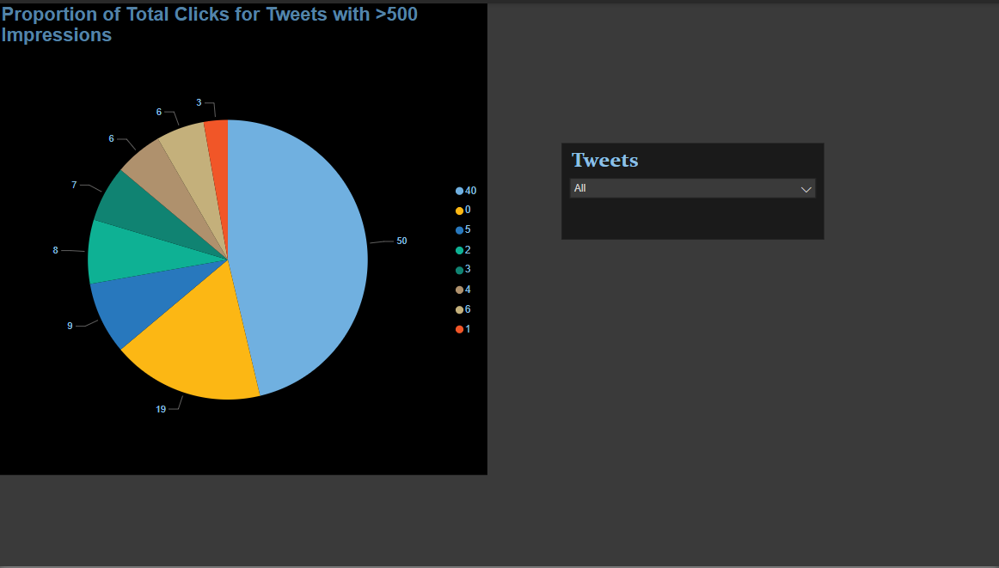

Task 2: Top 10 tweets based on retweets and likes

- Objective: The main aim is to produce and design an elaborate and graphical chart that will help users determine which tweets belong to the top 10 category based on the sum total of retweets and likes each tweet has accumulated. The chart will, therefore, be useful in explaining the most engaging and popular tweets in a given period.

- Key Features: This step would involve eliminating all the weekend posted tweets and make the analysis narrow down. It would ensure that the approach in analysis becomes more precise and targeted. In that case, the engagement of the users would be clearly understood considering only the weekdays.

- Display user profiles attached to each tweet so that the audience can easily identify who posted.

- Apply time-based filter such that the graph will only display between 3 PM IST and 5 PM IST.

- More Filters:

- The Tweet impressions must be even.

- The Tweet date must be odd.

- The count of words in the tweet less than 30.

- Steps

1. Formulate a measure column that takes out the weekend.

2. Add a new measure that accumulates the value of retweet and like sums.

3. Dynamically filter on Time, Impression, Date and Word Count

4. Use bar chart visualization.

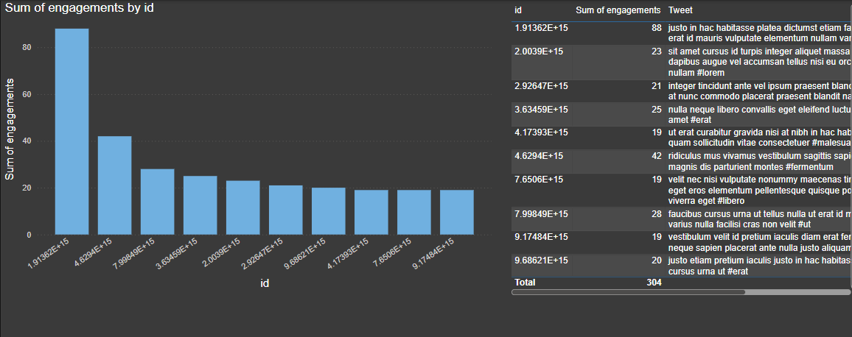

Task 3: Dual-Axis Chart of media views and Engagement

- Objective: The main aim is to present and display the sum total of media views together with the different media engagements that take place, specifically categorized by each day of the week for the previous quarter that has just concluded.

- Key Features:

- Important attention should be given to those specific days in which the noteworthy rise or spike is observed on the level of recorded media interactions.

- Besides that, the use of filters that depend on time intervals shall also be implemented. The required intervals shall be divided into two phases, one in between 7 AM and 11 AM as per IST and another in between 3 PM and 5 PM as per IST.

- Extra Filters:

- Note that the tweet impressions must also have a requirement of being odd in number.

- The date chosen for tweets must be odd.

- The total count of characters of the tweets should be more than 30.

- Remove all words that contain the letter 'H'.

- Procedure:

1. Develop media view metrics and engagement levels.

2. Use a dual-axis chart for visualization.

3. Use custom time filters and do text transformations in Power Query.

4. Use conditional formatting to highlight noticeable spikes.

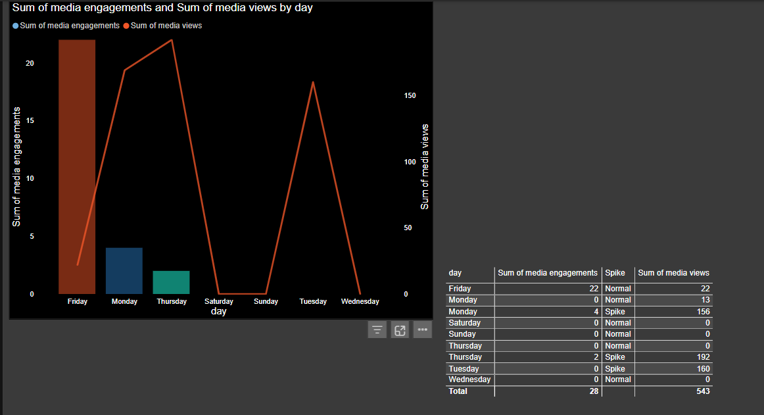

5. Skills learned

- Data Cleaning and Transformation in Power Query.

- DAX formula development for calculated columns and measures.

- Visualization methods to develop interactive and responsive dashboards.

- Advanced filtering and time-based data modeling.

- Problem-solving using analytical and logical reasoning.

6. Competencies Developed

- Proficiency in Power BI for data visualization.

- Understanding of Twitter data analytics.

- Enhanced communication skills through effective reporting and dashboard storytelling.

- Strong technical and organizational skills for handling complex datasets.

7. Feedback on Null Class Training

Null Class provided excellent training and support during the internship. The project-based learning approach made it practical and engaging. The instructors were accessible and responsive to queries, thus ensuring clarity in concepts and problem-solving techniques.

8. Challenges and Solutions

Challenge 1: Incomplete or inconsistent data.

Solution: Used Power Query to clean and transform the dataset, fill null values, and remove redundancies.

Challenge 2: Advanced filters for dynamic visualizations.

- Solution: Used DAX to its full potential, including the powerful filtering capabilities within Power BI, so that the conditional logic could be very precise and accurate.

Challenge 3: Time constraints meant most visualizations were not feasible.

- Solution: Wrote custom time measures using DAX, which could hide visuals if they were out of the set time ranges.

9. Results and Impact

Developed a highly dynamic Twitter Analysis Dashboard that can be used effectively to show important insights regarding tweet performance and engagement metrics.

Better understanding of social media analytics, as well as the full potential offered by Power BI.

Provided actionable insights in the form of clean, interactive, and well-structured visualizations.

10. Conclusion

I learned much regarding the analysis and visualization of data during my internship at Null Class. The development of the Twitter Analysis Dashboard gave me firsthand experience using Power BI to solve real-world problems, and this has armed me with the skills and the confidence to lead data-driven projects in professional environments.